- Resolve Merge Conflicts &
- Create a merge conflict intentionally (two users editing the same line).
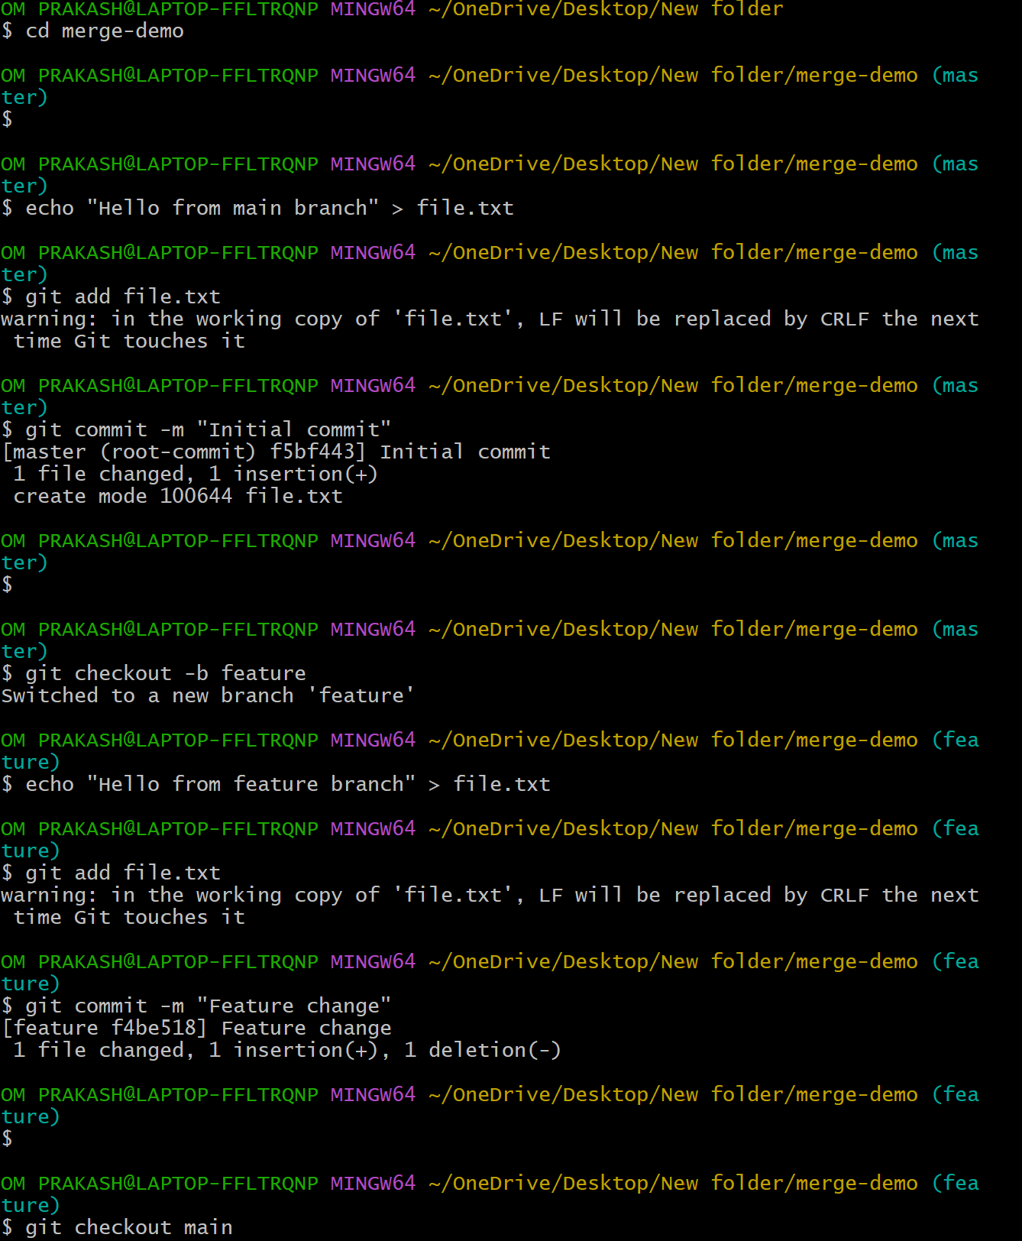
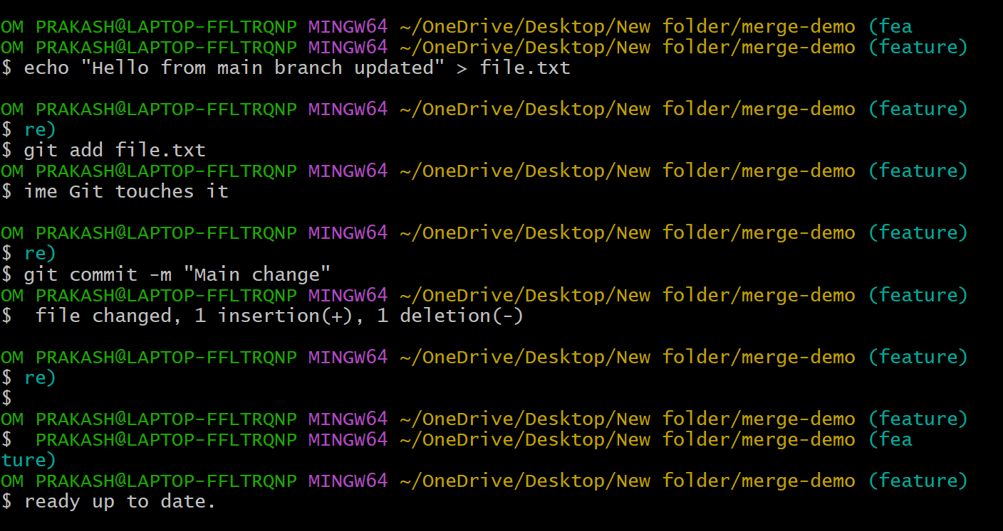
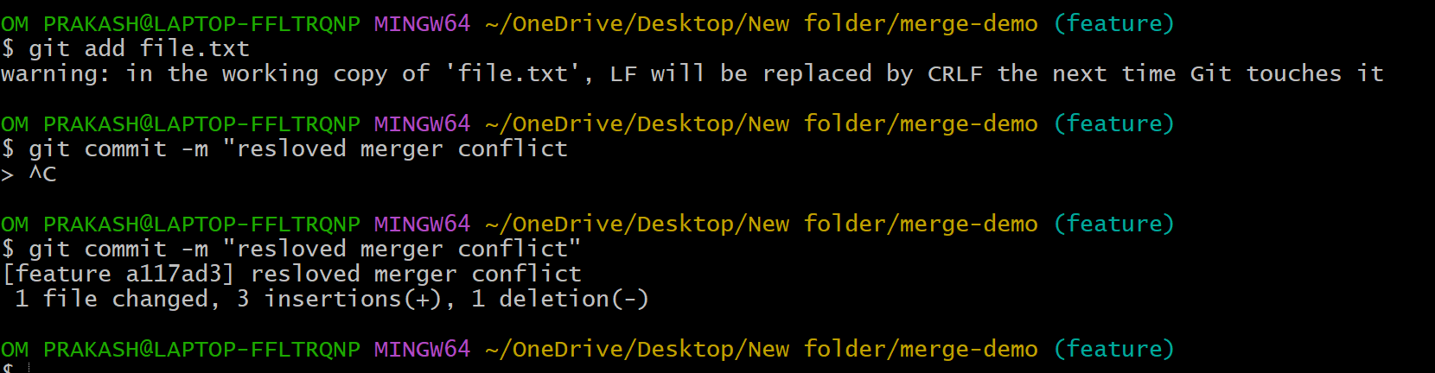
- Resolve the conflict and push the changes.
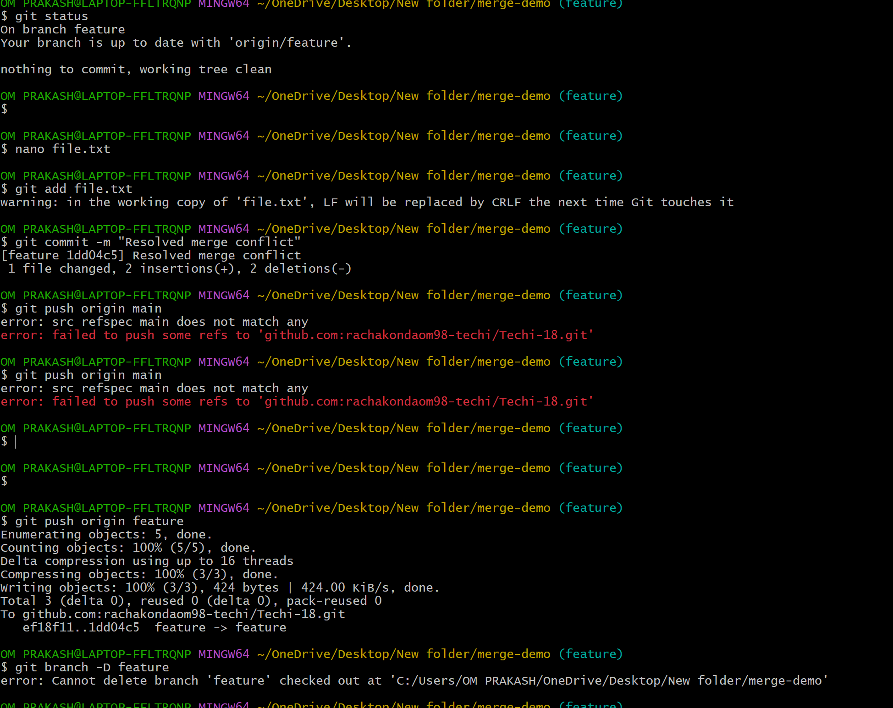
- Recover Deleted Branch
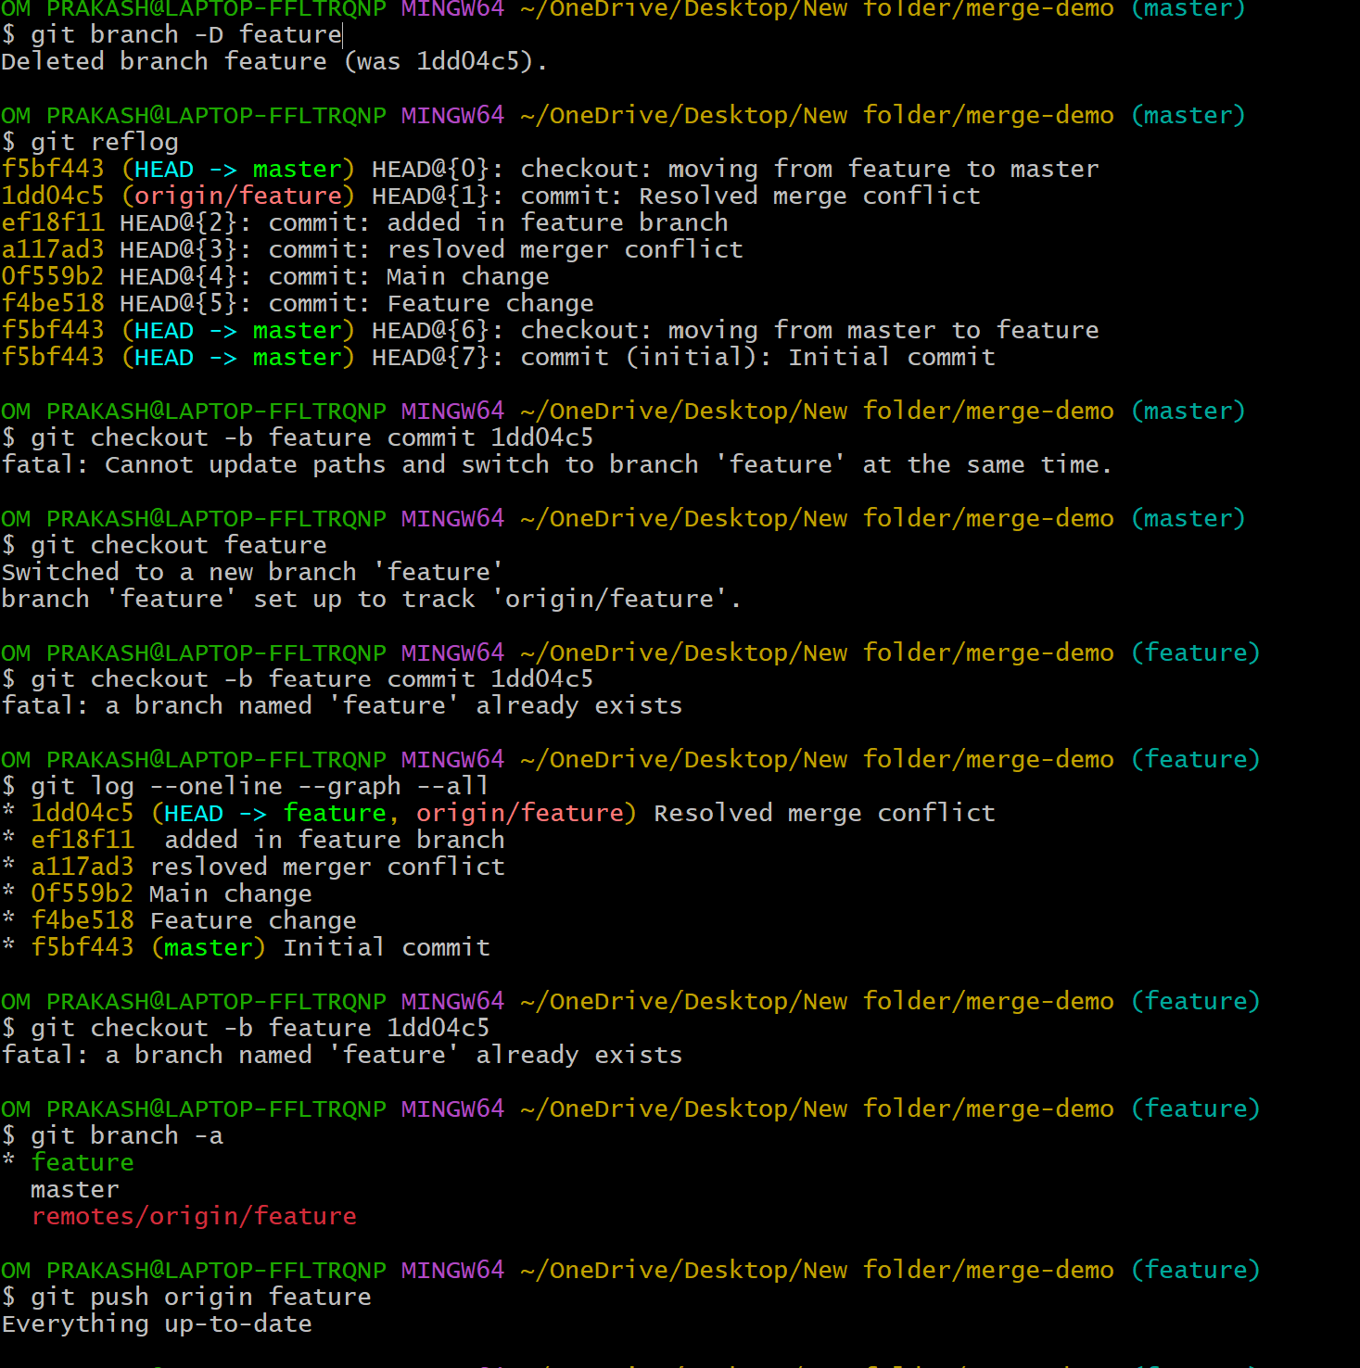
- Delete a local branch and then recover it using the reflog.
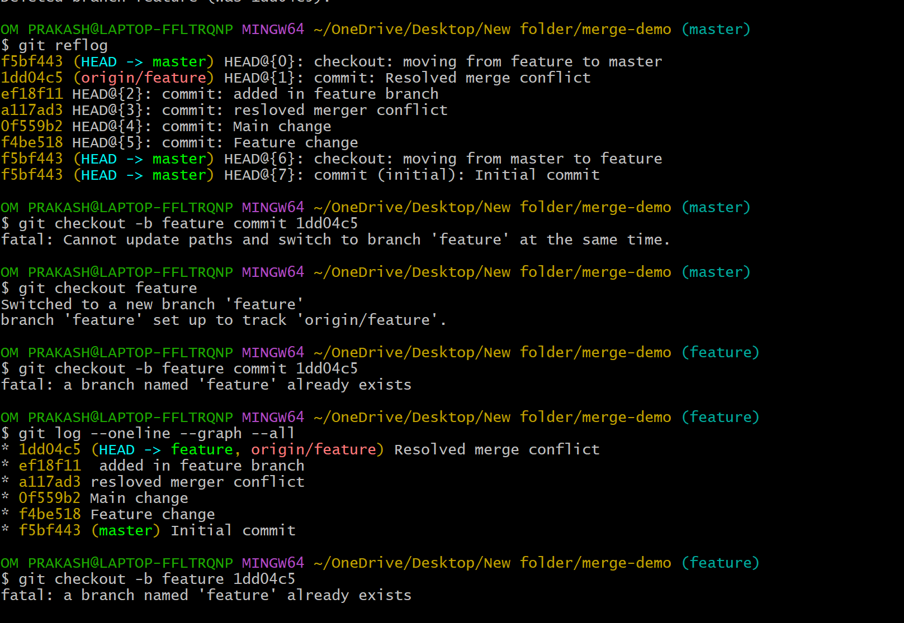
- Undo Wrong Push
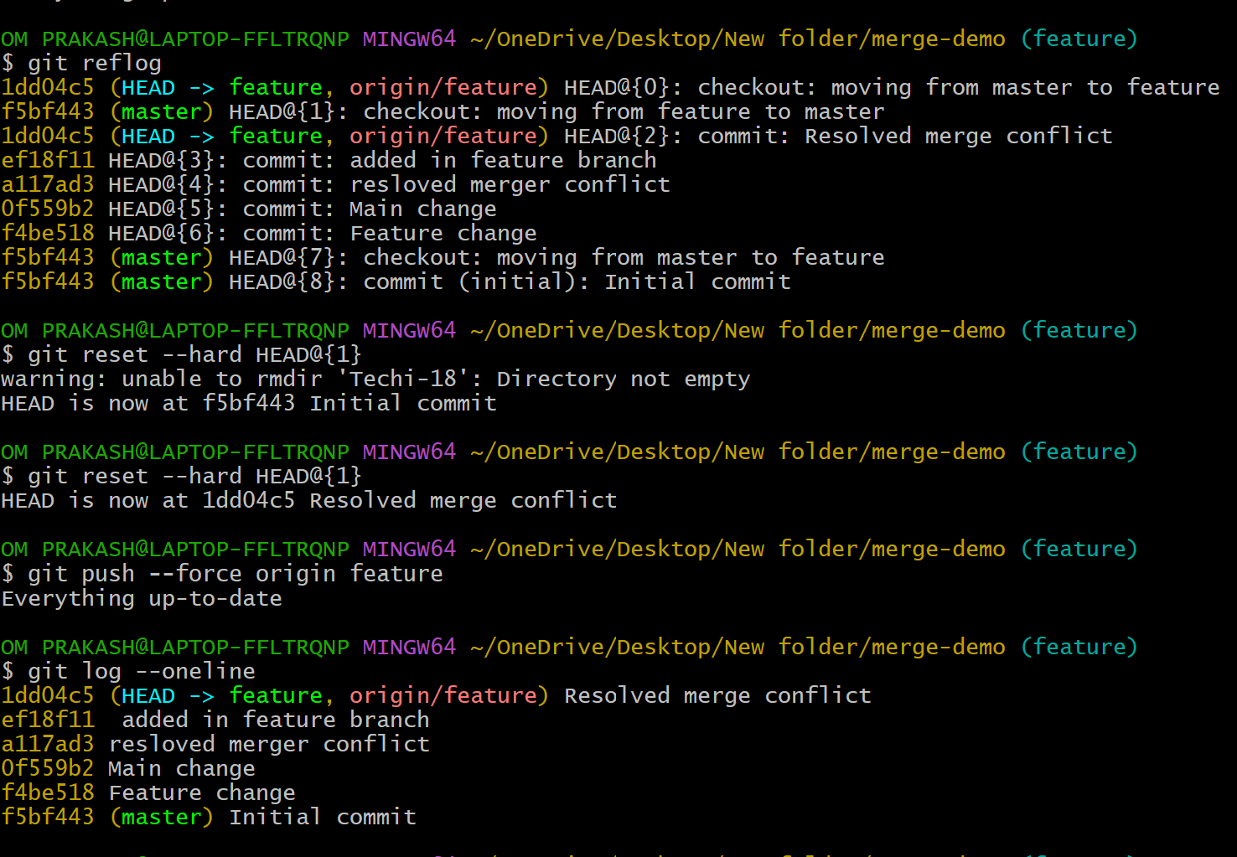
- Push a wrong commit to GitHub, then undo it without losing history.
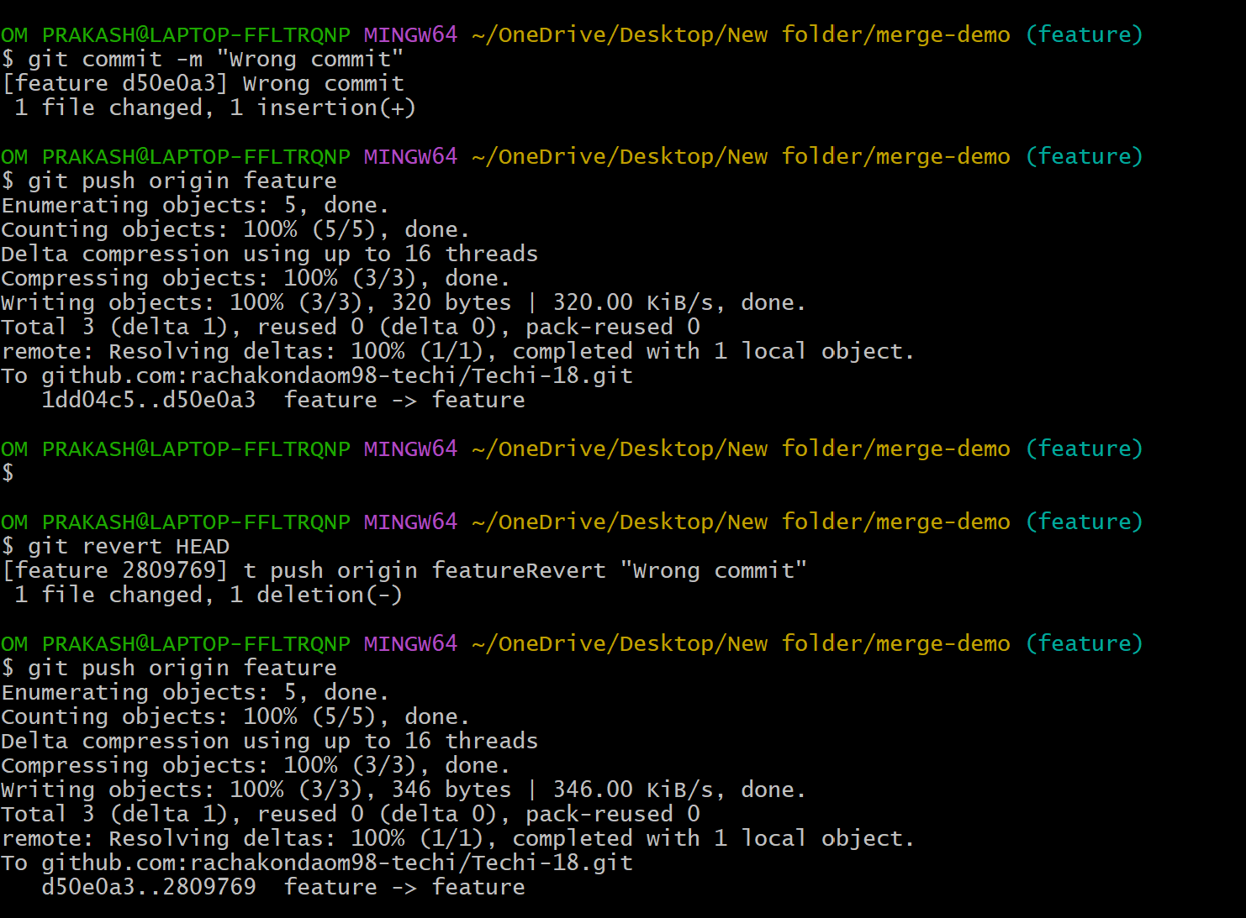
Amend a Commit
- Make a commit, then add a missing file to it using git commit --amend.
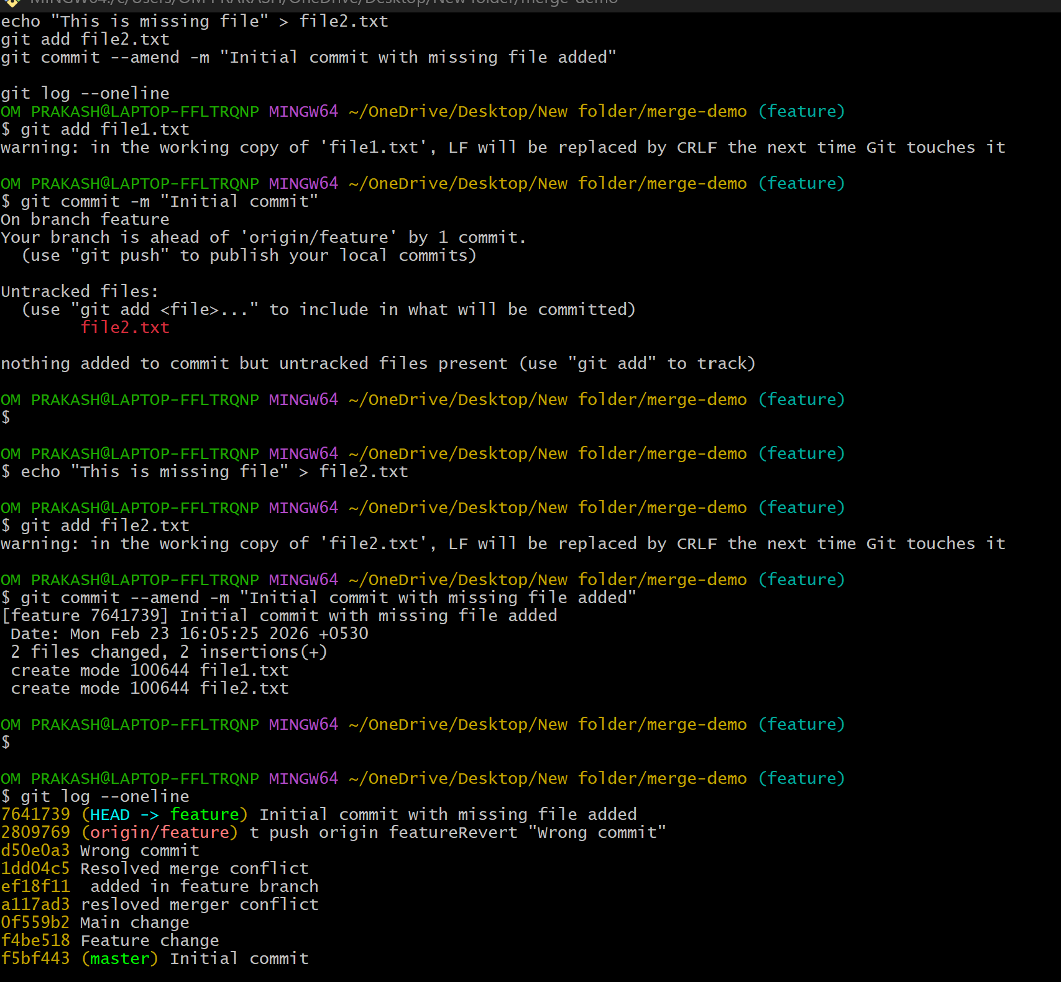
- Cherry-pick a Commit
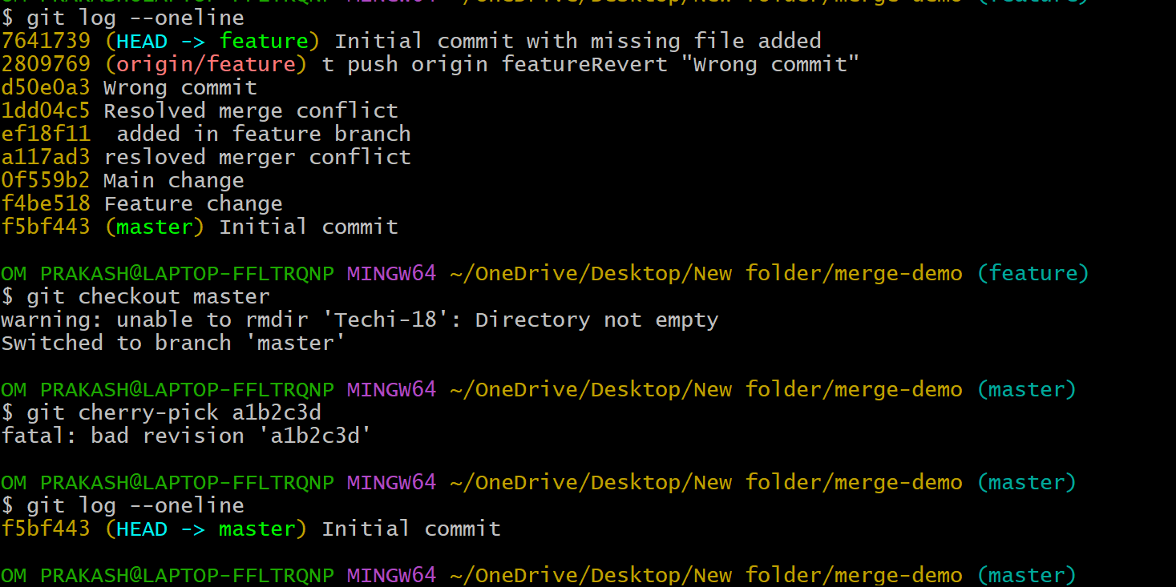
- Take a specific commit from one branch and apply it to another branch.
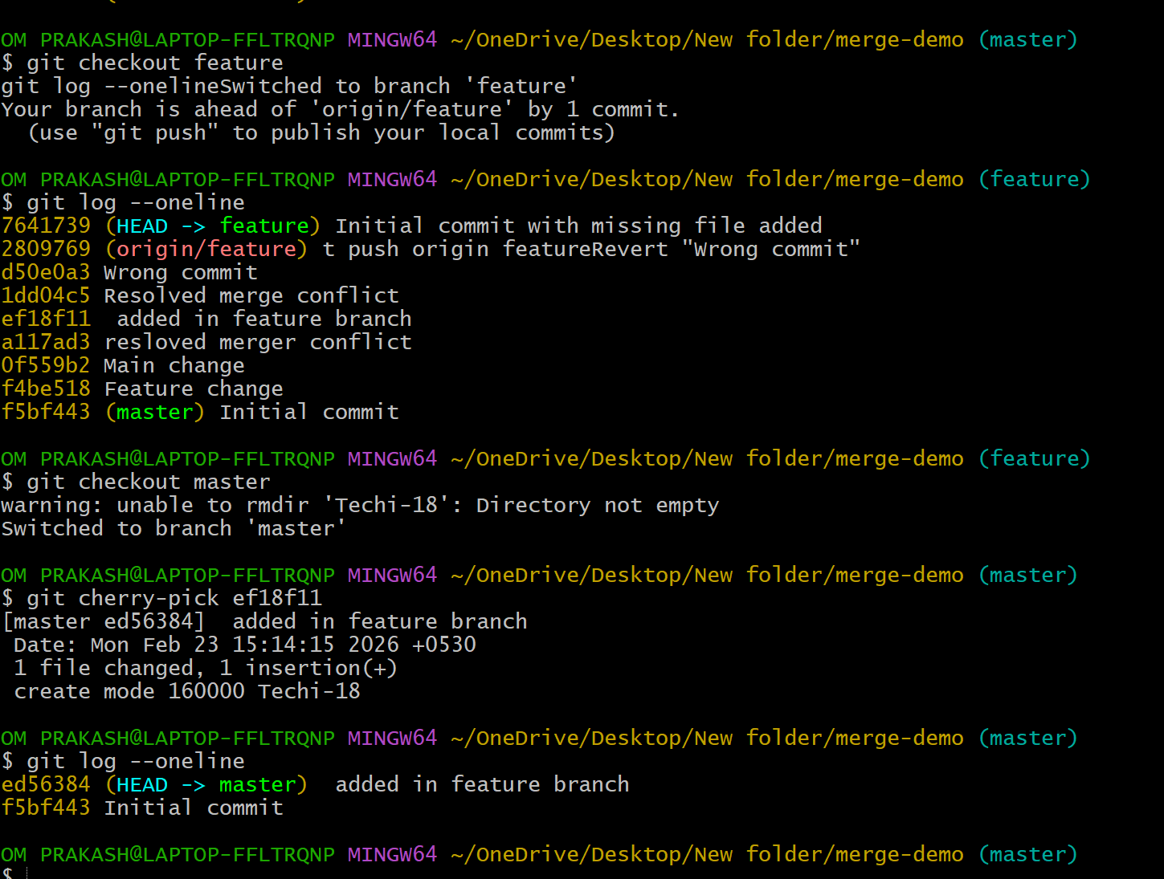
- Interactive Rebase
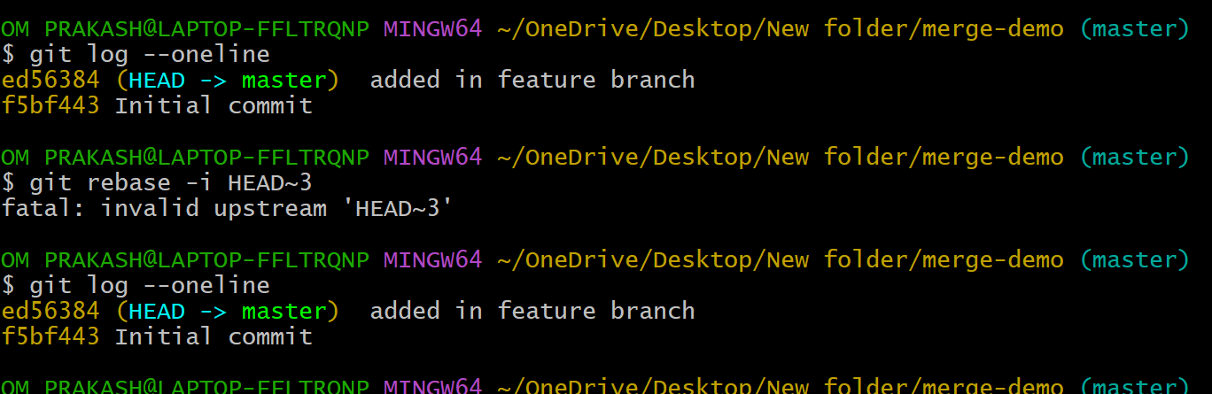
- Reorder and squash multiple commits into a single clean commit.
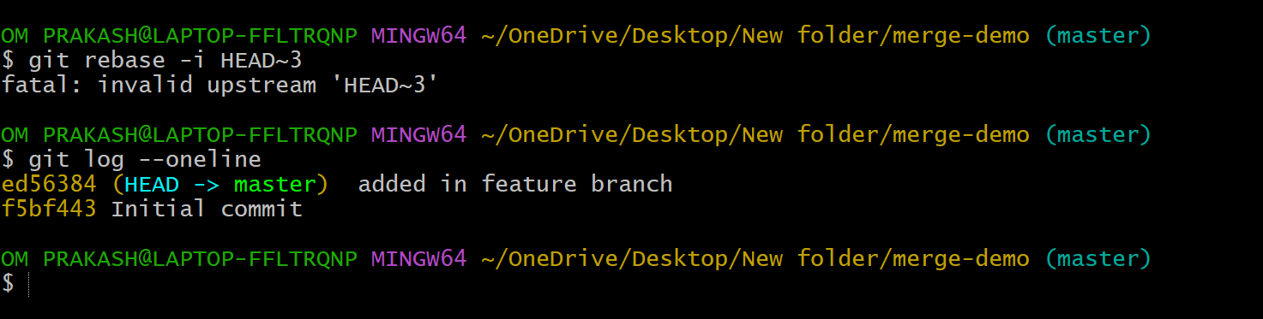
- Tagging & Release
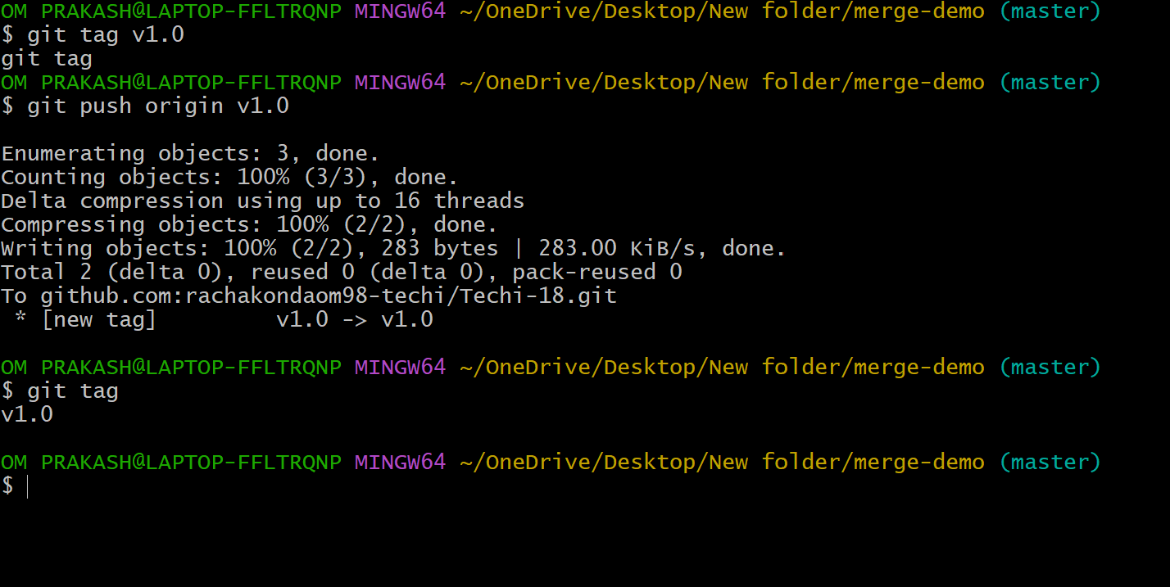
- Create a version tag (v1.0), push it to GitHub, then delete and restore it.
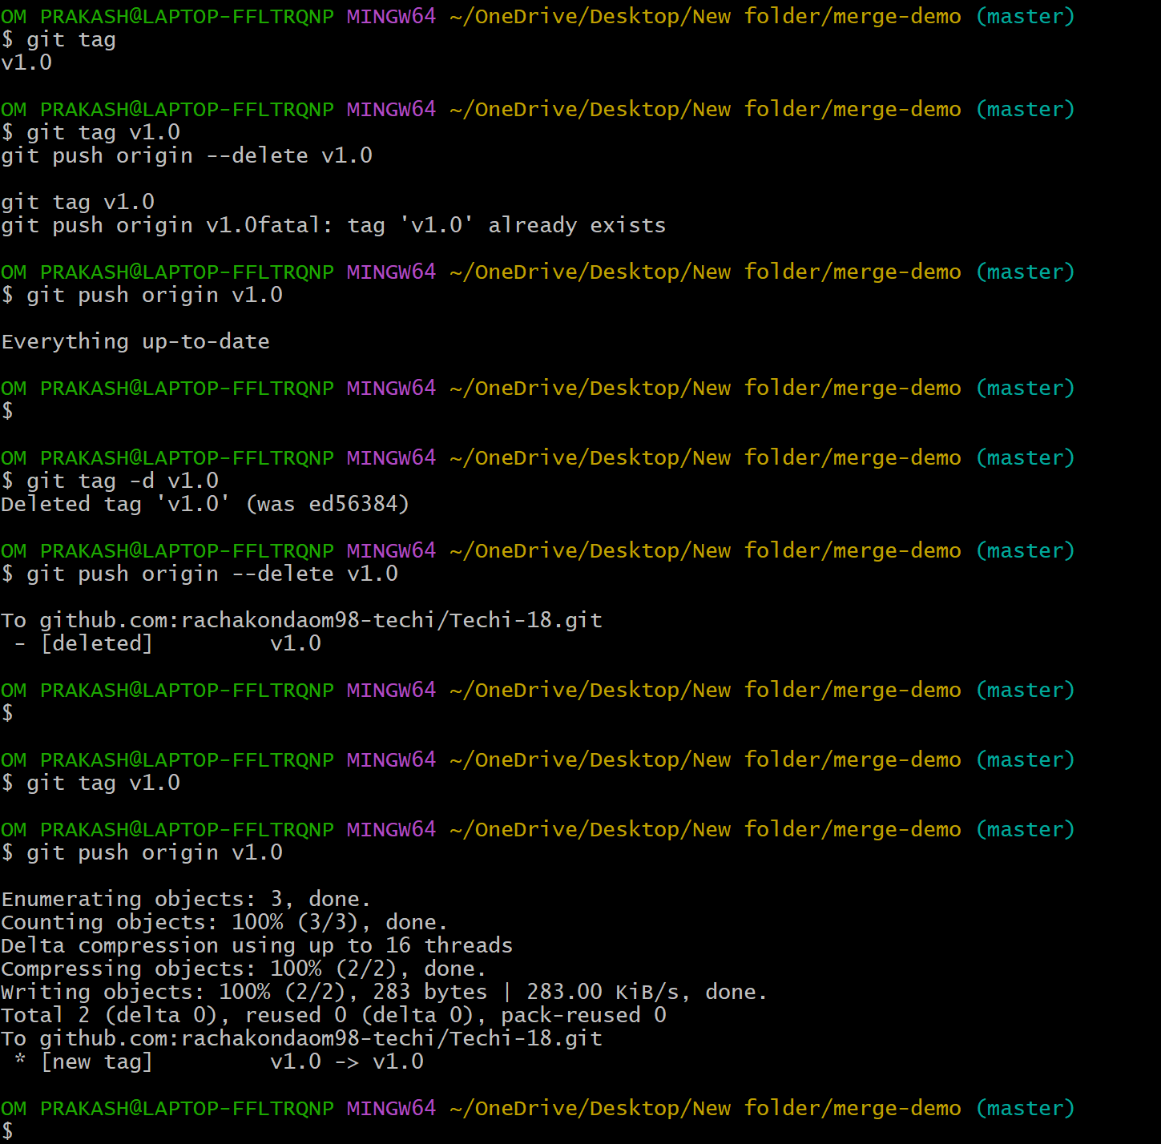

- Clone with Sparse Checkout
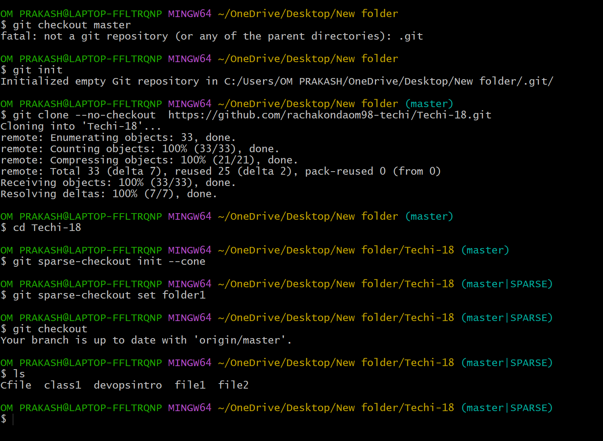
- Clone only a subdirectory of a repo using sparse checkout.
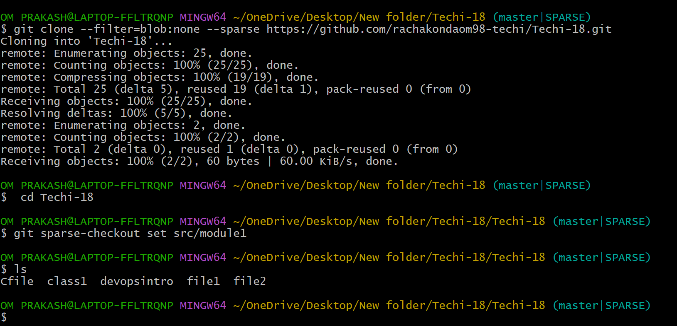
Reset vs Revert Challenge
- Demonstrate the difference between git reset --hard and git revert in a repo.
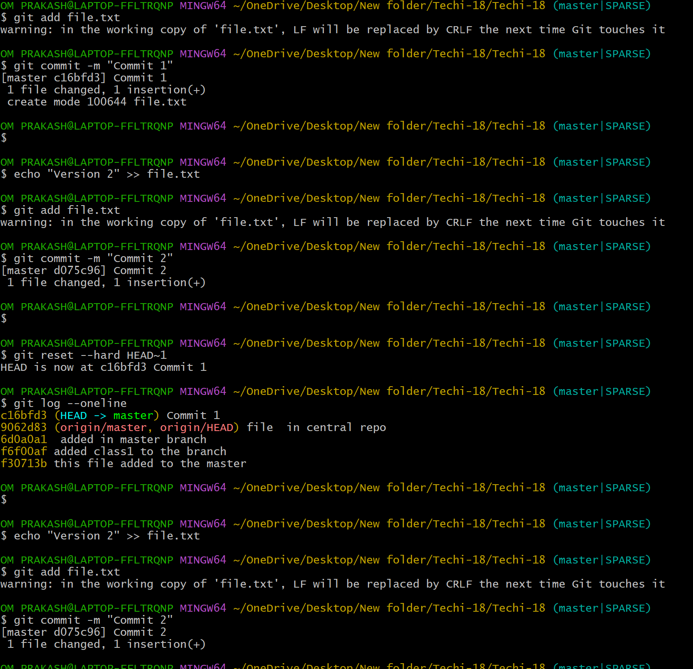
- Detached HEAD Challenge
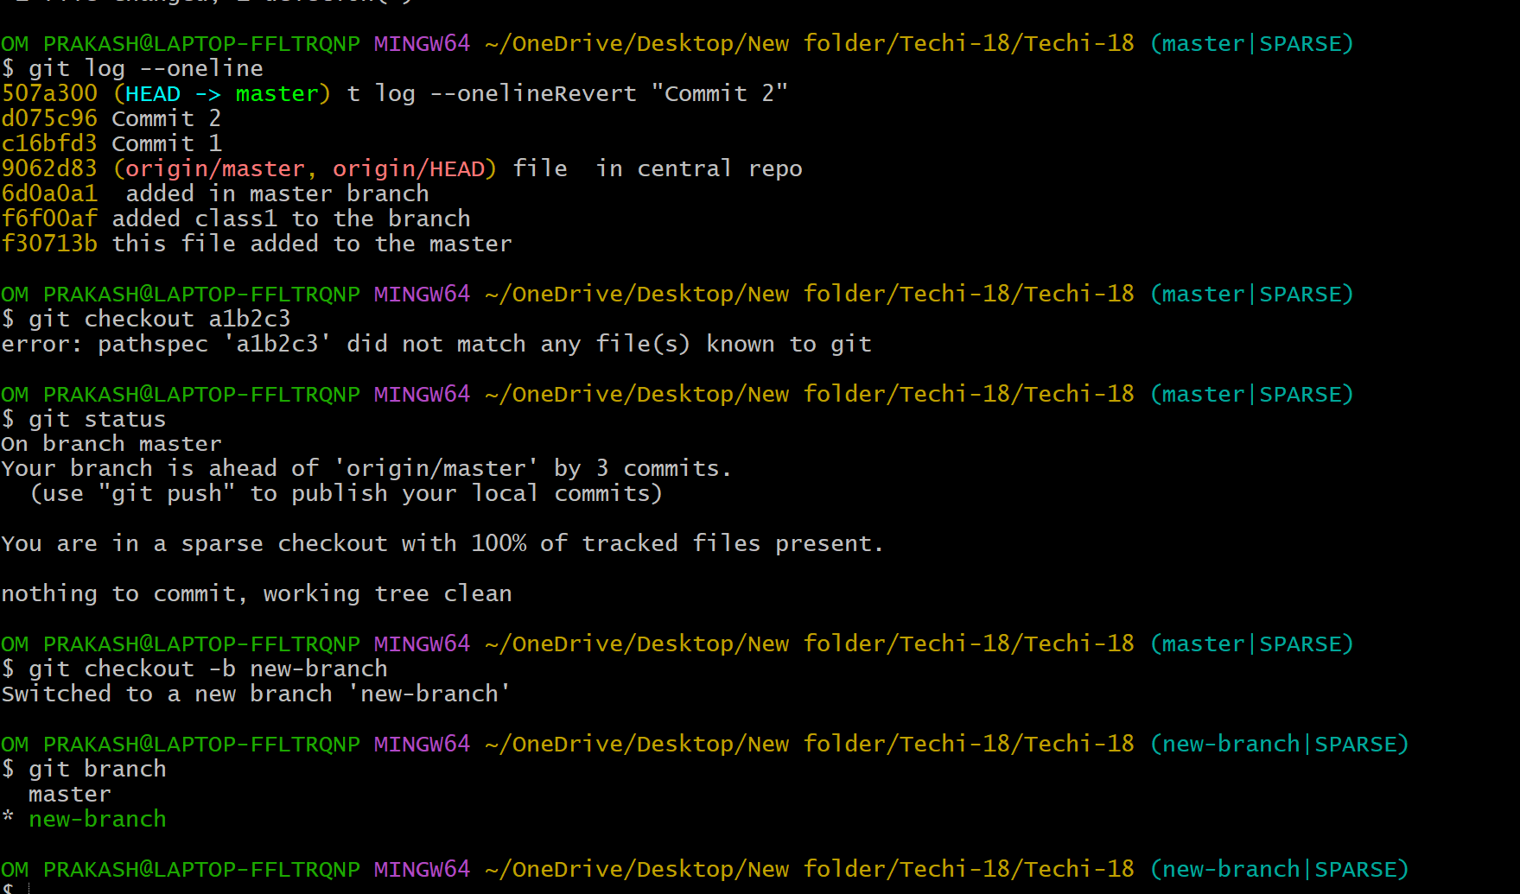
- Checkout a specific commit (detached HEAD state) and create a new branch from it.
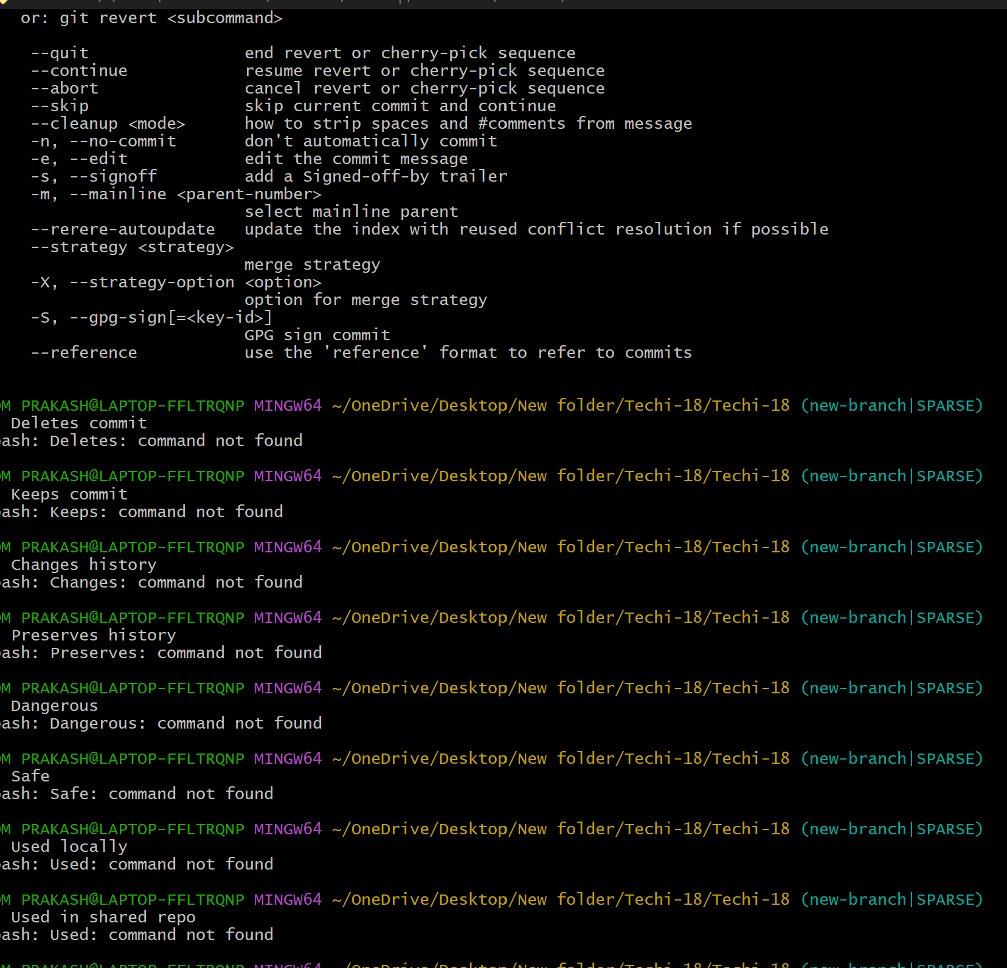
Git Hooks Challenge
- Configure a pre-commit hook to reject commits without a message format (e.g., must start with JIRA-XXX).
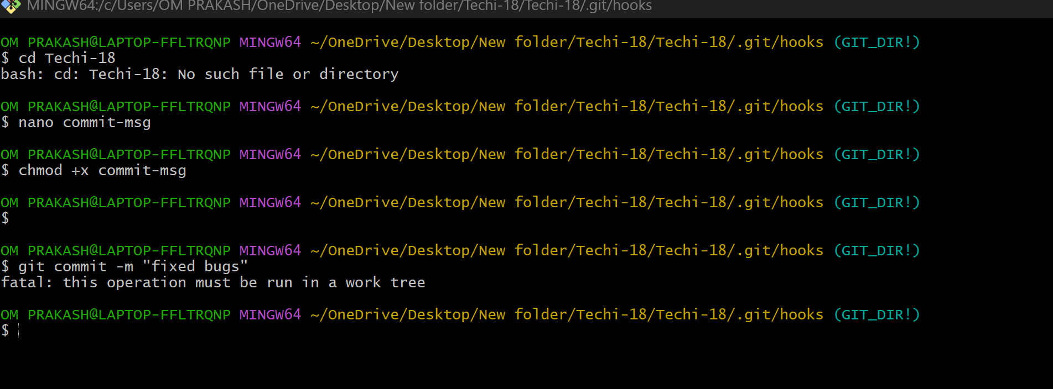
- Squash Merge vs Rebase Merge
Squash Merge
Combines multiple commits into one commit
Creates clean and simple history
Old commits are not visible after merge
Used to avoid too many commits
Best for production branch (main/master)
Rebase Merge
Keeps all commits separate
Moves commits to top of main branch
Creates linear history
All commits are visible
Best for development tracking

- Show the difference between squash merge and rebase merge with evidence.
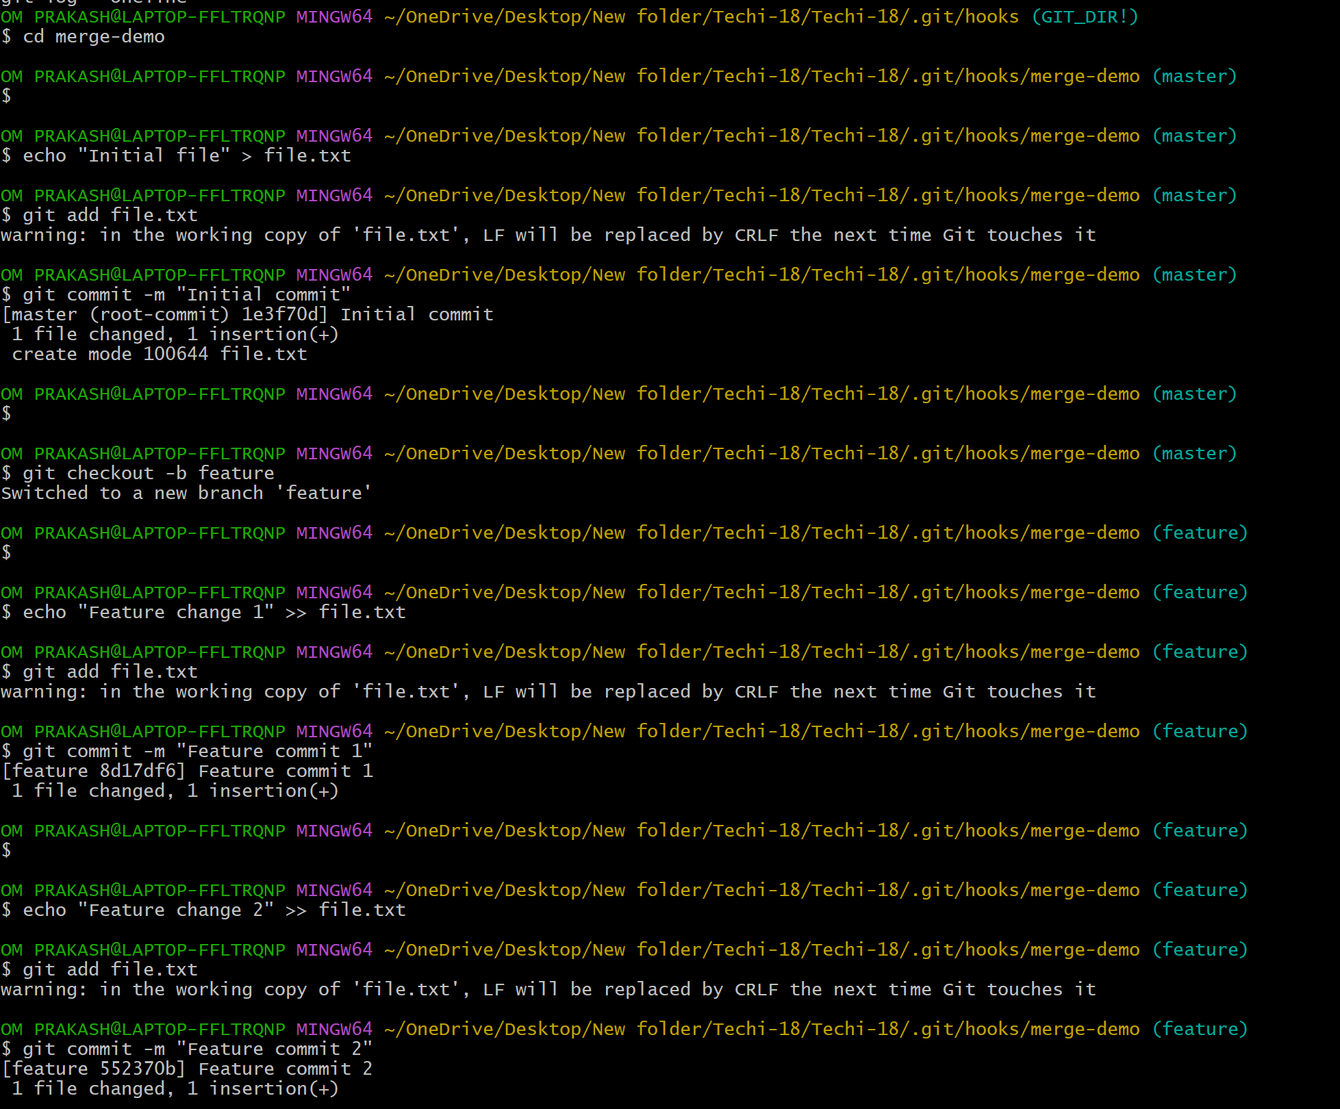
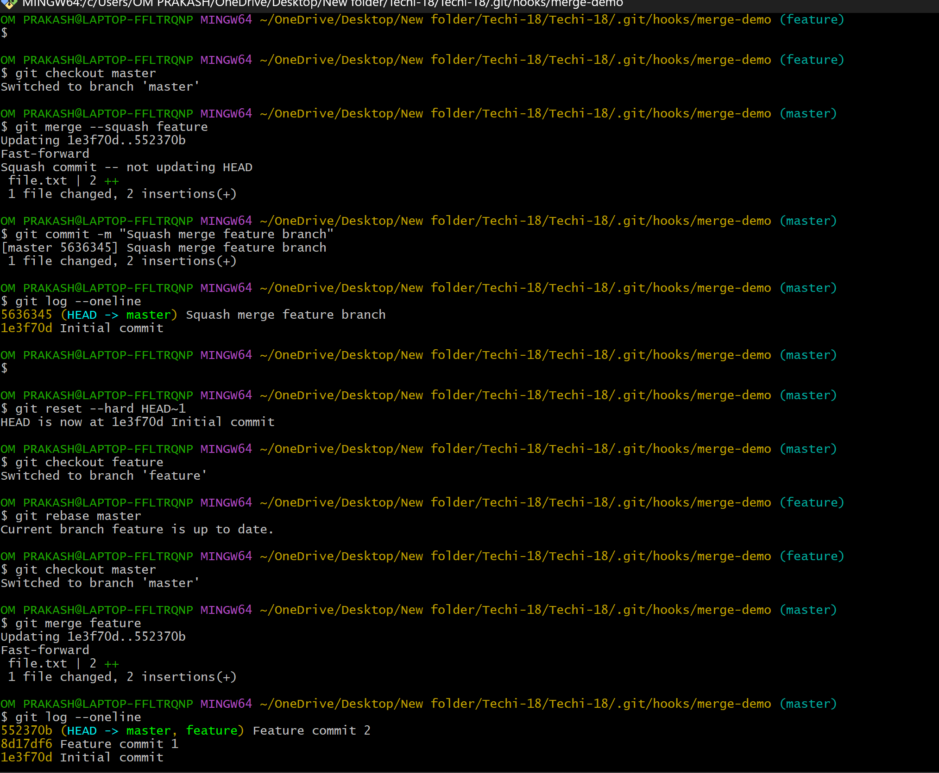
- Fork & Pull Request Workflow
Ans : Fork → Clone → Create Branch → Make Changes → Commit → Push → Pull Request → Merge
- Fork a repo, make a change, and submit a pull request to the original repo.
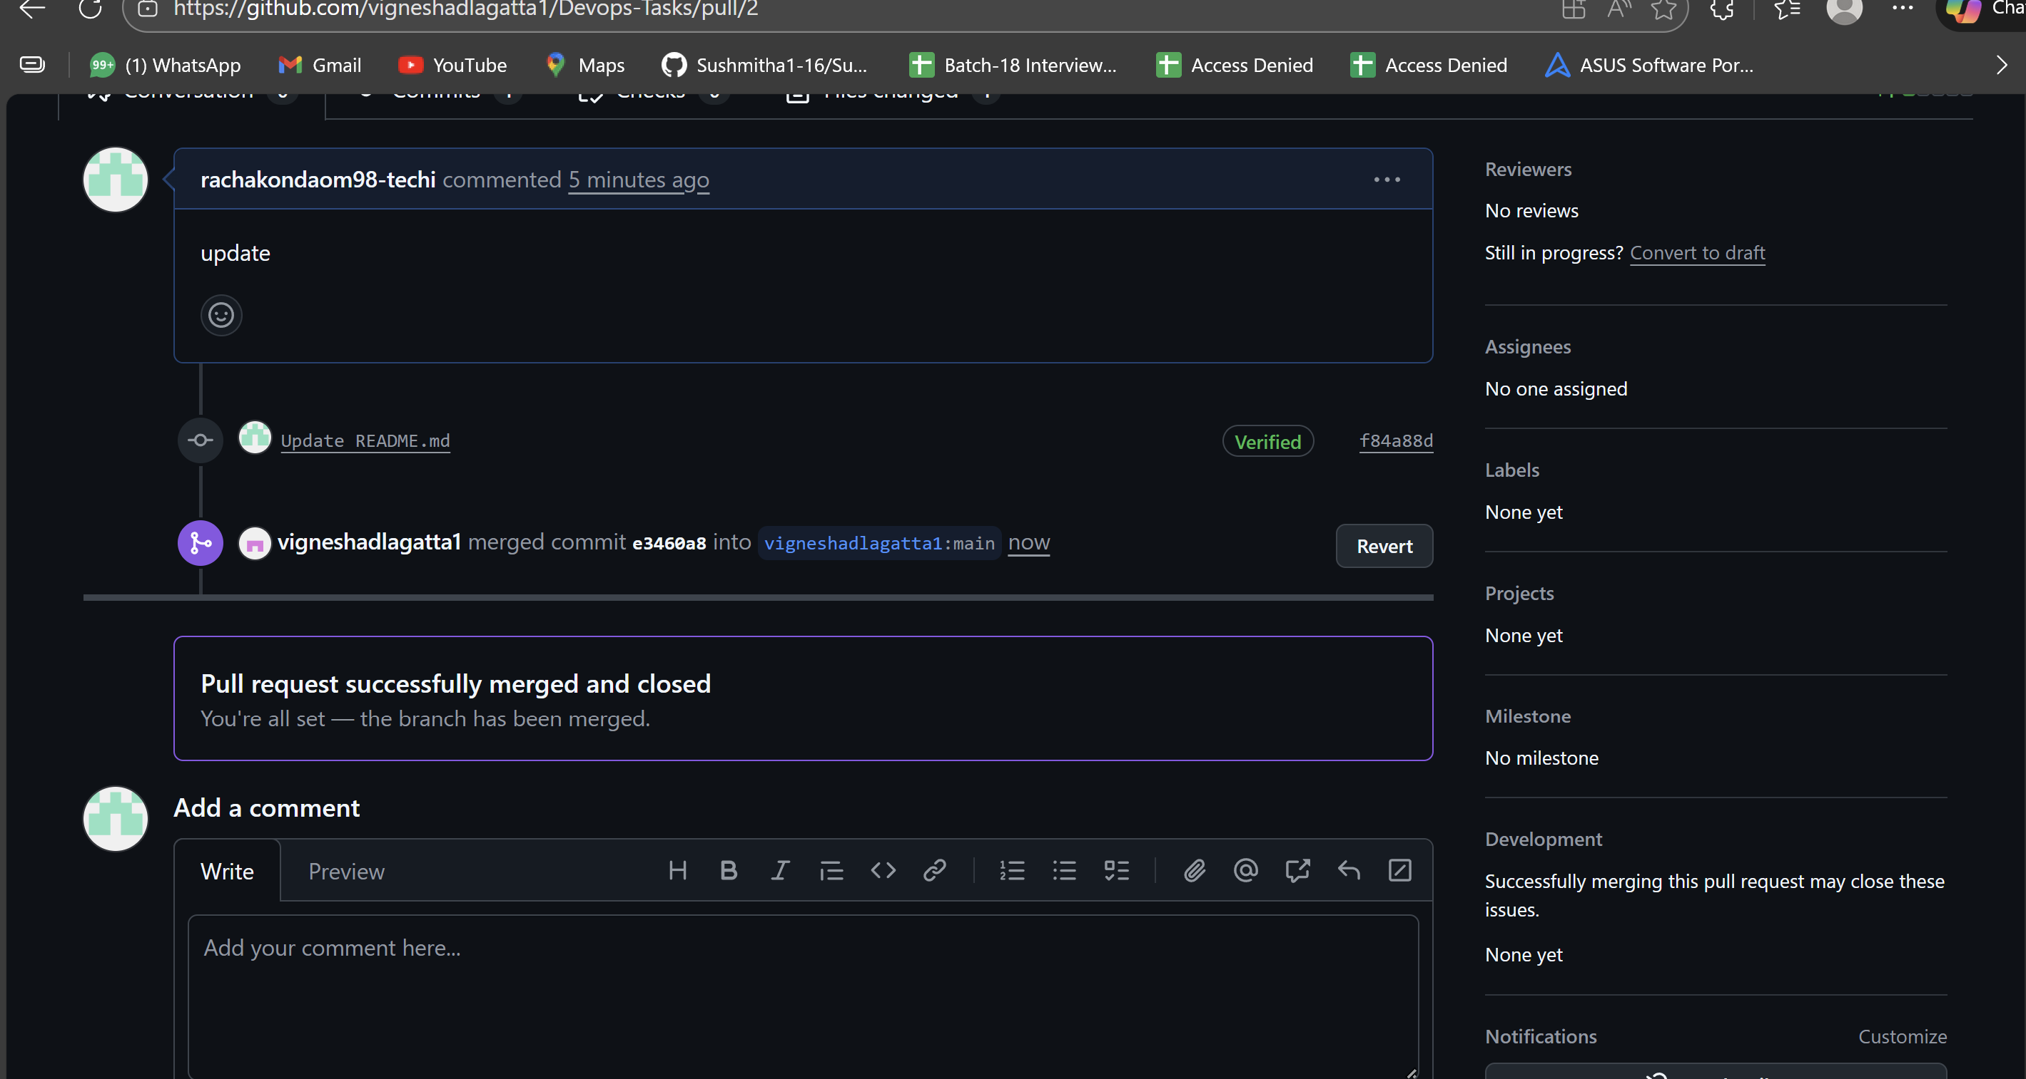
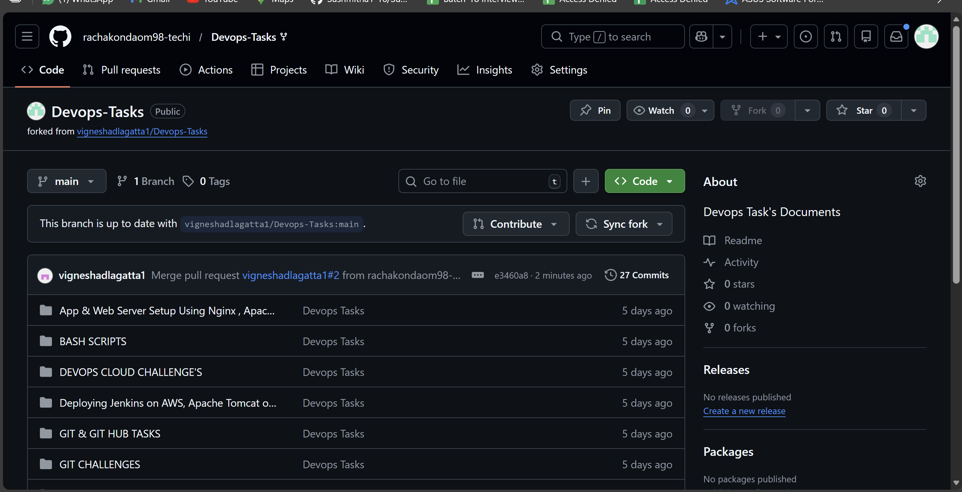

Recover Lost Commit
- Commit something, reset hard, and then recover it using git reflog.
